Bone Fracture Detection System

In this project as per your instructions we have created doctor and patients modules and both users will perform following operations

1. Doctor Sign up: doctor can sign up to the application and then will login and then can see all records of patients who have given permission to this doctor
2. Password encryption: all doctors password will be stored in database in encrypted formats
3. Patient Sign up: patient can sign up to application and all passwords will be encrypted
4. Patient Login: patient can login to system
5. Upload X-Ray: patient can upload x-ray to system and then choose desired doctor to give permission to access his x-ray. YOLO deep learning algorithm will be applied on X-Ray image as ASSITANCE to detect type of Fracture and then it will show severity with bounding boxes. All detection results will get saved in database.
6. View Patient Report: using this module doctor can view all patients X-Ray report.

SCREEN SHOTS

To run project install MYSQL database and then open MYSQL console and then copy content from ‘database.txt’ file and then paste in MYSQL to create database

To run project double click on run.bat file to start server and get below page

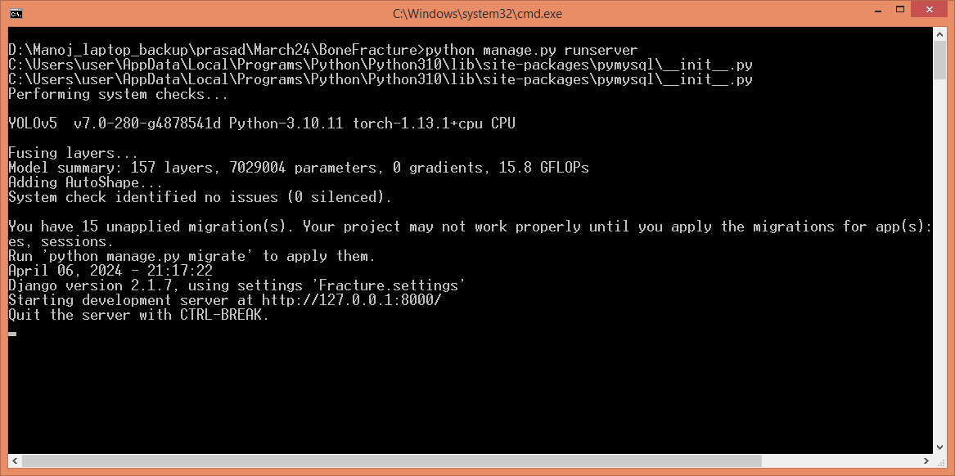In above screen python server started and now open browser an enter URL as <http://127.0.0.1:8000/index.html> and press enter key to get below page

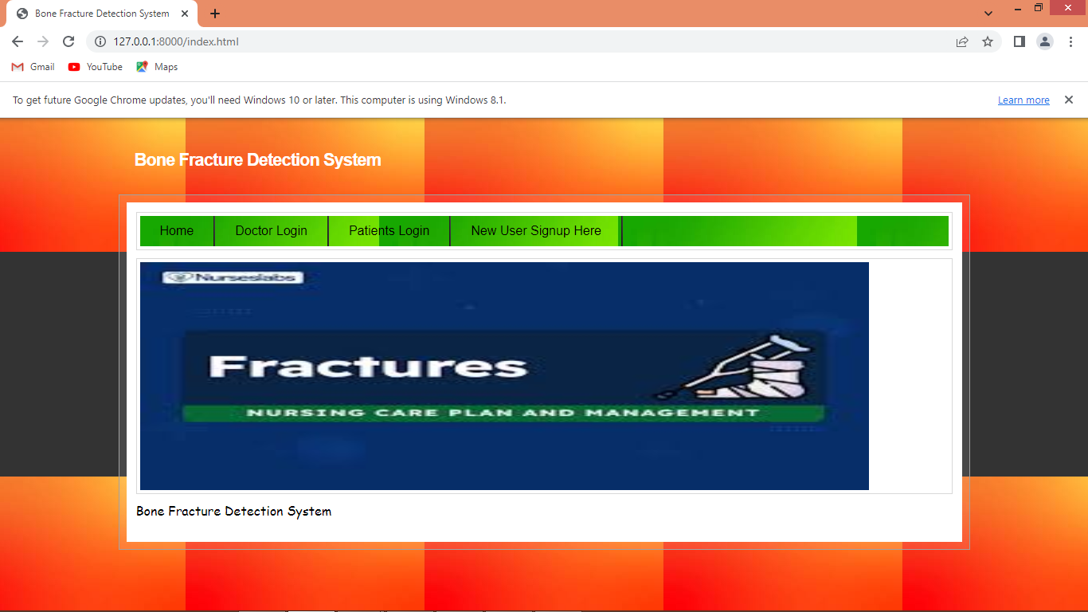

In above screen click on ‘New User Sign up’ link to get below page

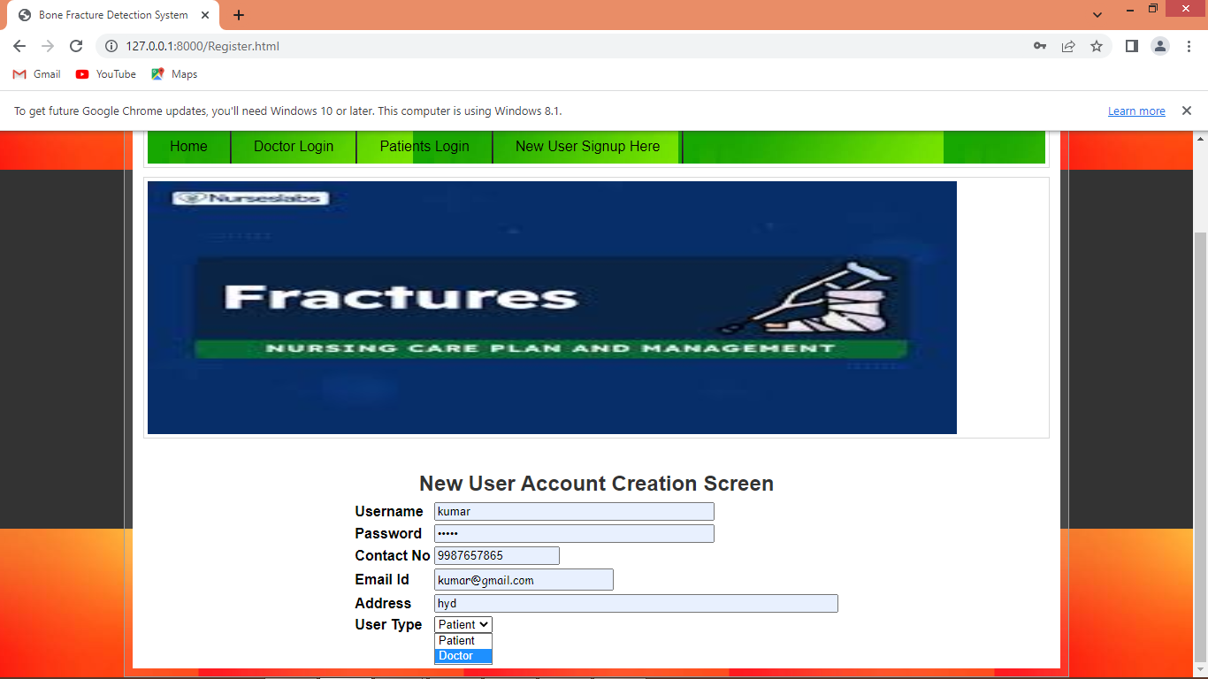

In above screen adding doctor details as sign up and then press button to get below page

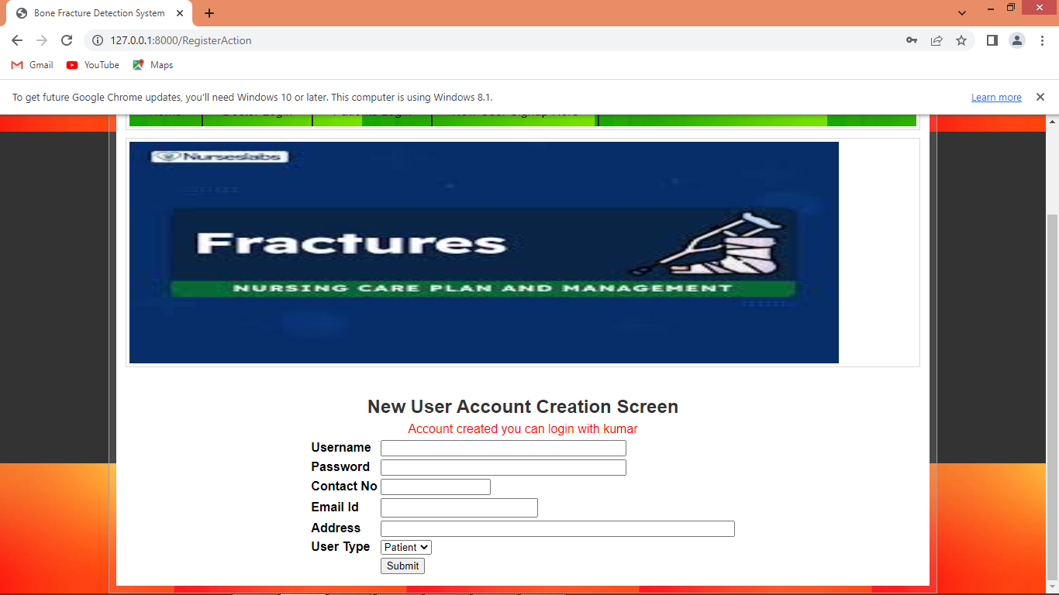

In above screen doctor account created and similarly you can add patient account also

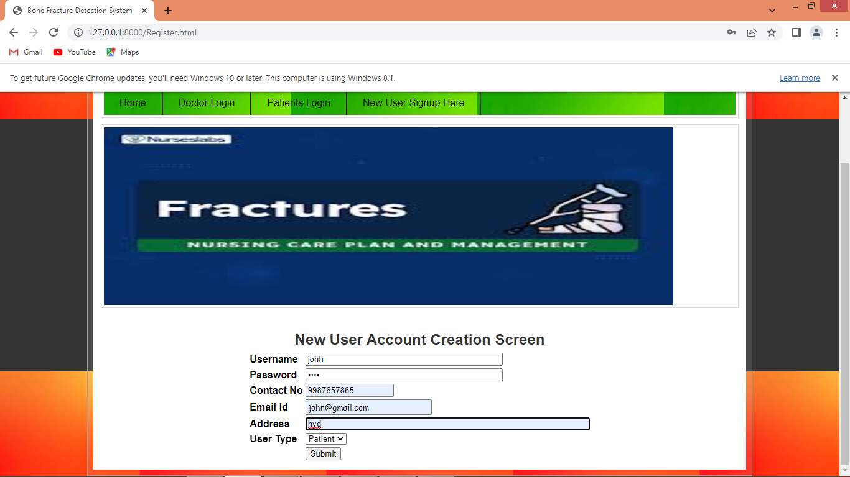

In above screen adding patient details and then press button to save sign up in database and then in below database screen can see password is encrypted

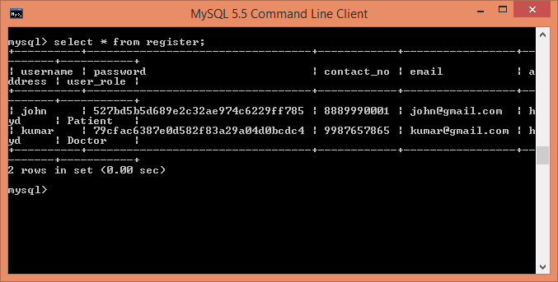

In above database screen can see password column contains encrypted password instead of plain password. Now click on ‘Patient Login’ link to get below page

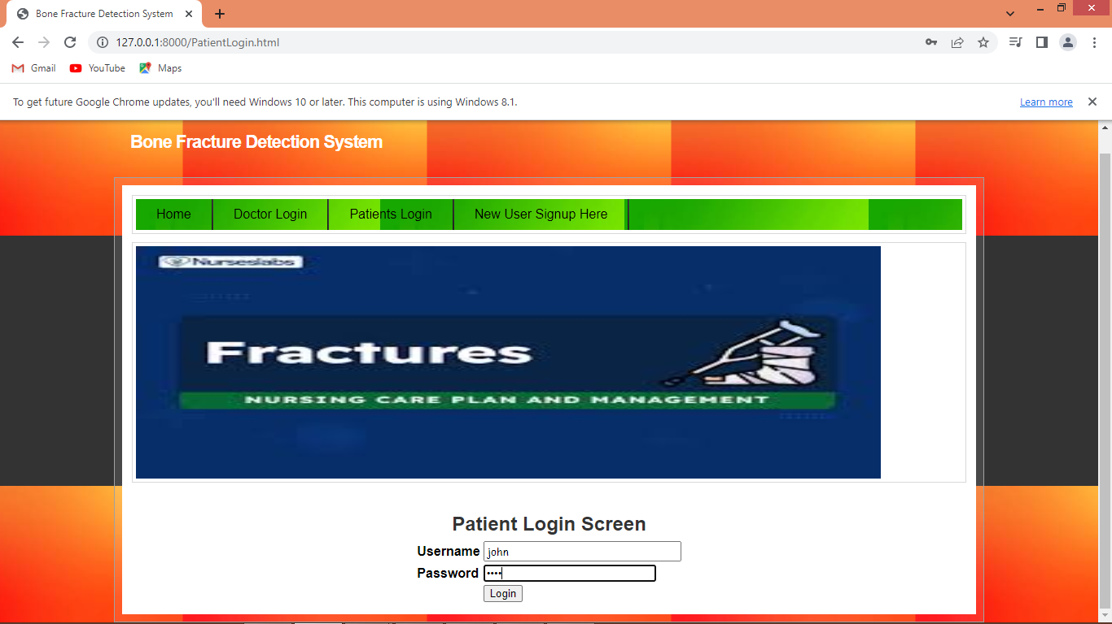

In above screen patient is login and after login will get below page

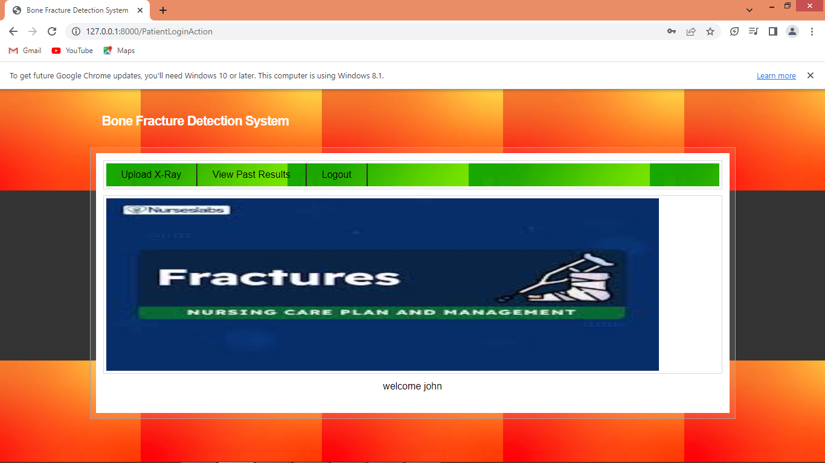

In above screen patient can click on ‘Upload X-Ray’ link to get below page

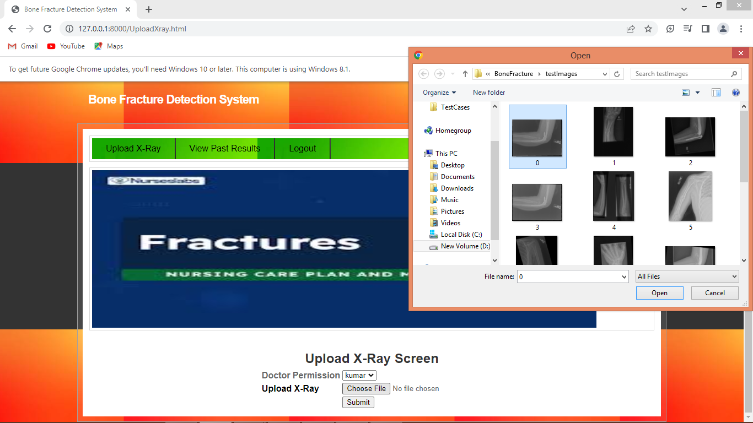

In above screen patient can select desired doctor name to give permission and then upload fracture image and then press button to get below assistance and submit same assistance report to doctor

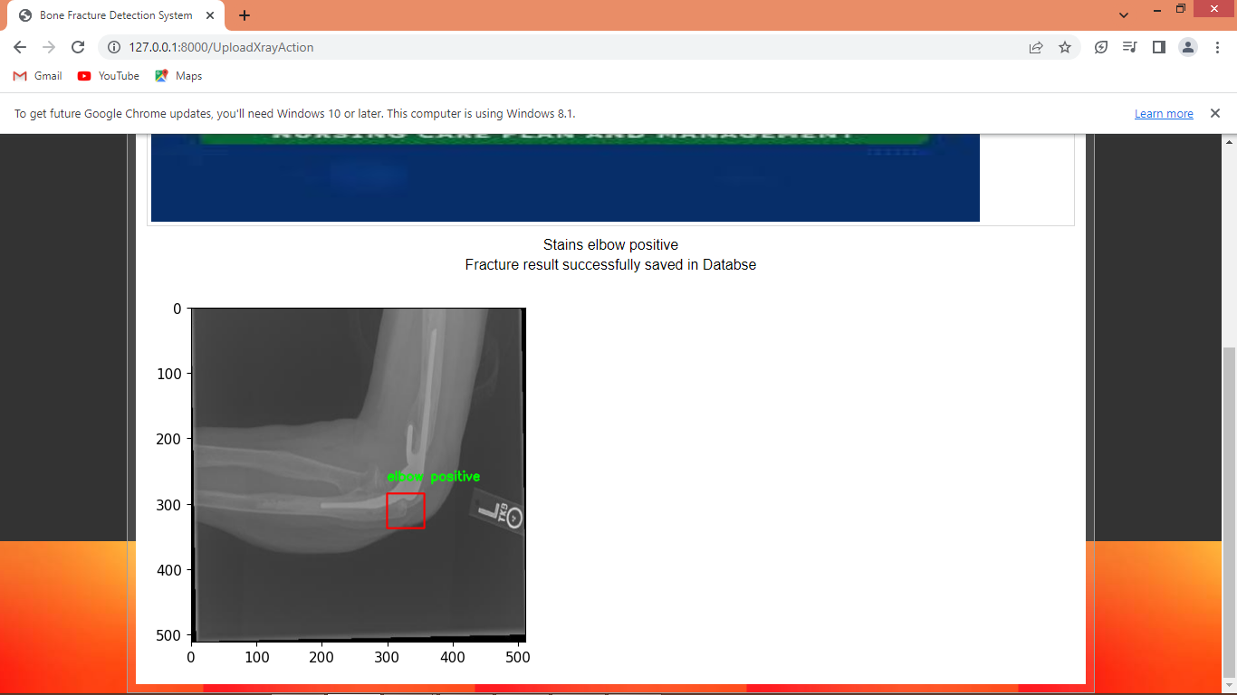

In above screen Assistance detected fractured as ‘Elbow Positive’ and similarly patient can upload any number and in below screen uploading another image

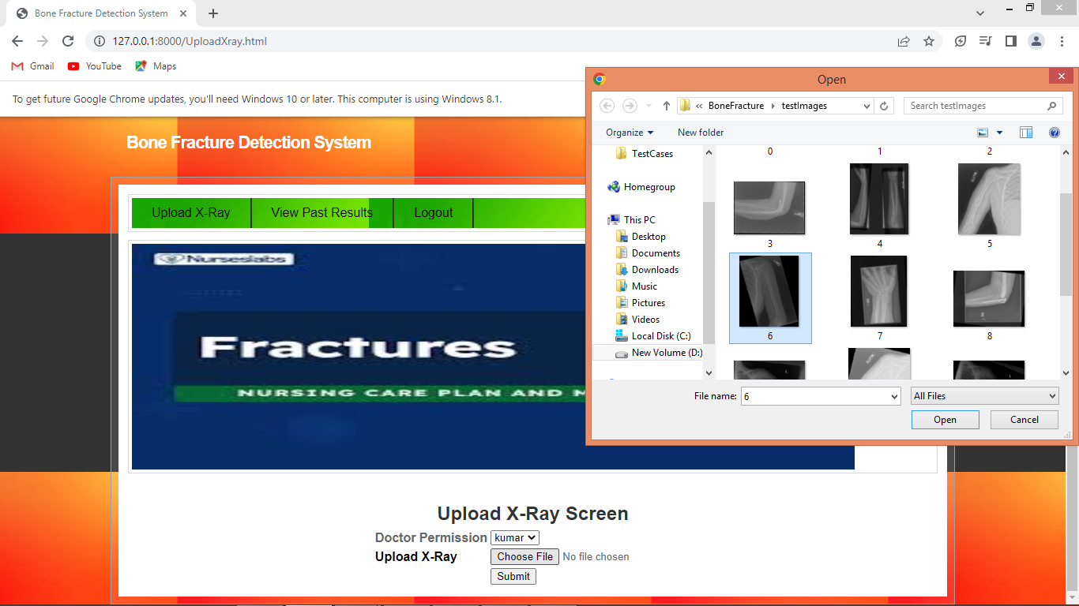

In above screen patient is uploading another image and then click on ‘Submit’ button to get below assistance

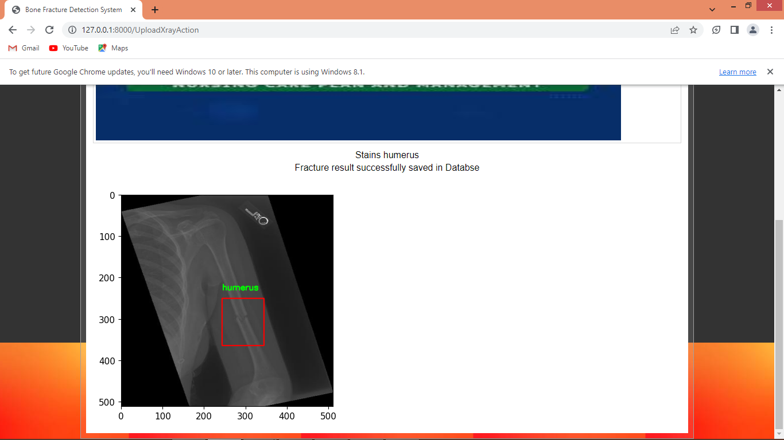

In above screen ‘humerus’ fractured is detected and similarly you can upload and test other images and now click on ‘View Past Results’ link to view past history X-Ray images uploaded by patients

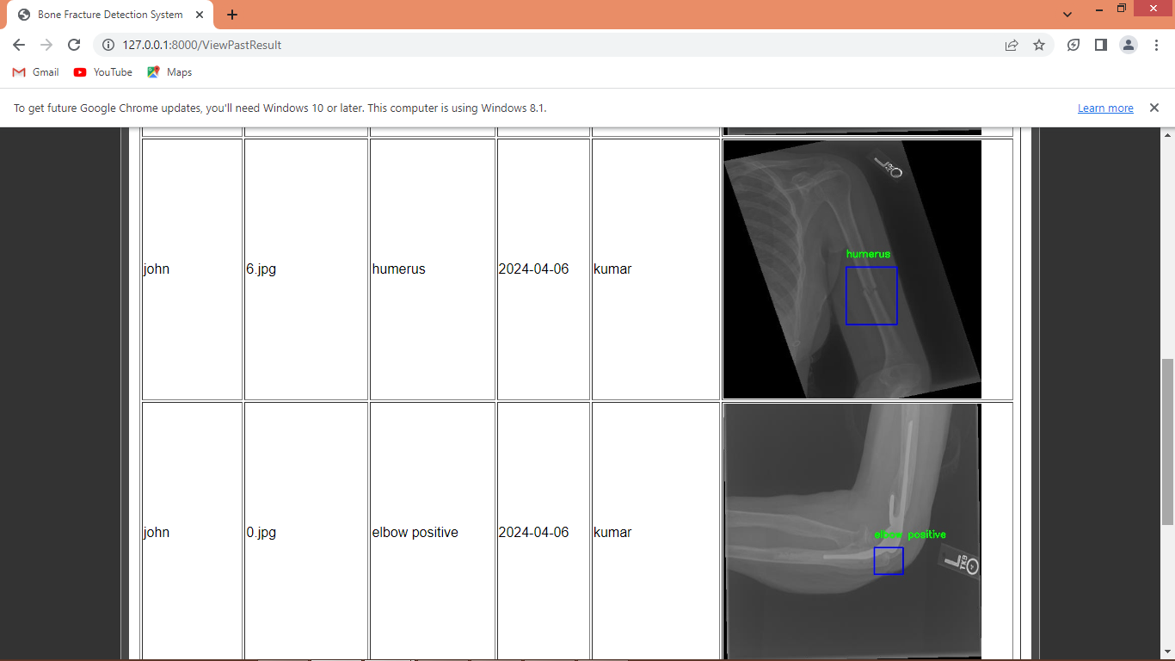

In above screen patient can view all past results with fracture detection results and permitted doctors and similarly doctors can login and can view all reports permitted by patients and now logout and login as ‘Doctor’

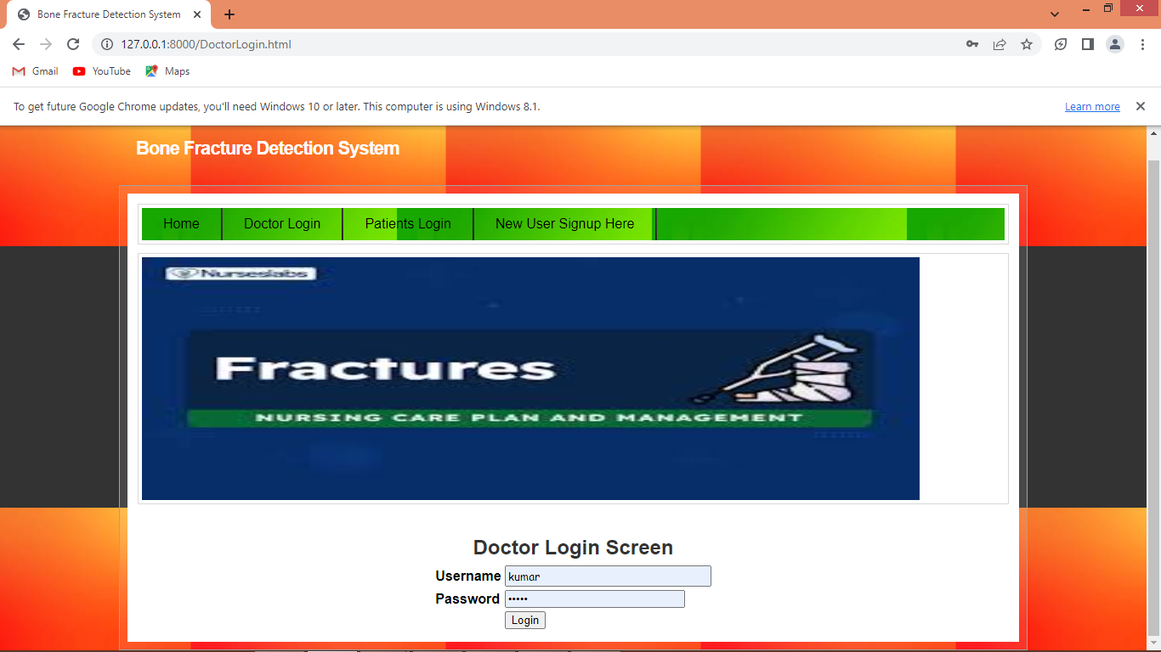

In above screen doctor is login and after login will get below page

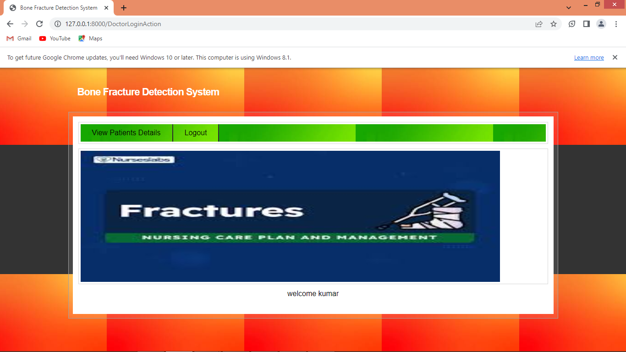

In above screen doctor can click on ‘View Patients Reports’ link to view all patients data

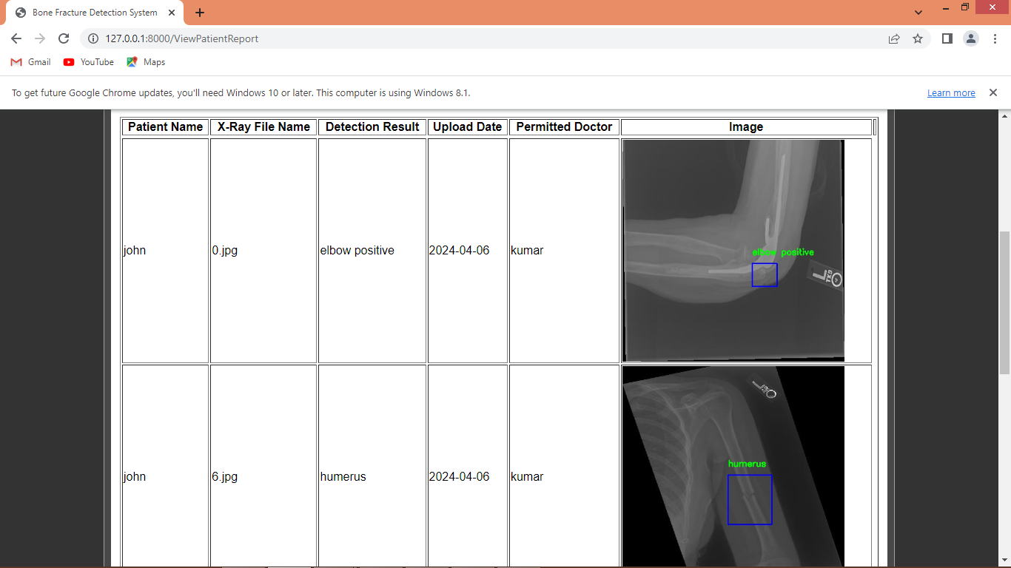

In above screen doctor can view reports of all patients and based on detected fractured he will suggest some prescription.